SmartCare v0.3 - Domain Model Workbook
Week 6 student resource

Requirement-to-Concept Trace
Requirement | Concept | State/behaviour | Decision
FR-01 | Patient | Attributes: patientID, name, contactNumber, dateOfBirth, status. Behaviour: createRecord(), updateRecord(), archiveRecord() | Patient included as a core class. "Delete" as archiveRecord() per the Stage 2 assumption that history must be preserved.
FR-02 | Appointment | Attributes: appointmentID, date, time. Behaviour: book() | Appointment modelled as an association class linking one Patient and one Practitioner, rather than an attribute on either class.
FR-03 / FR-09 | Appointment, Availability | Behaviour: checkConflict(); a booking is rejected and an error shown if a clash is found | Conflict-checking logic placed on Appointment, collaborating with Availability. FR-09's error message is a UI consequence of this behaviour, not a separate class.
FR-04 / FR-13 | Availability | Attributes: dayOrDate, startTime, endTime. Behaviour: addSlot(), updateSlot(), checkOverlap() | New class Availability introduced (the optional class) to hold a practitioner's scheduling rules separately from the Practitioner class itself.
FR-05 | Appointment | Behaviour: reschedule(newDate, newTime) | Modelled as a state-changing operation on the existing Appointment object. No new relationship or class required.
FR-06 | Practitioner, Patient, Appointment | Behaviour: viewSchedule(), viewPatientRecord() | Practitioner collaborates (read-only) with Patient and Appointment. No new attribute needed since history is derived from existing associations.
FR-07 | Appointment | State: status = {Scheduled, Confirmed, Completed, Cancelled, NoShow}. Behaviour: cancel(), book() | Status modelled as an attribute typed by the AppointmentStatus enumeration rather than a separate class, since the values have no independent behaviour.
FR-08 | (excluded) | N/A | Access restriction is a security concern, not a business-domain concept, so no class is added for it.
FR-11 | Patient ↔ Appointment | State: appointment history = the set of Appointment objects linked to a Patient | Represented as a association from Patient to Appointment rather than duplicating the data in a separate "History" class.
FR-12 | (excluded from core model) | N/A | The Stage 2 assumption, an operational report is a generated summary over existing Appointment data, not a persistent domain class, so it is left out of the class diagram.

CRC Cards

Patient
Responsibilities | Collaborators
Store and provide own personal & contact details (name, DOB, contact number) | —
Request a new appointment booking | Appointment
Request cancellation of an existing appointment | Appointment
View own appointment history (read-only) | Appointment

Practitioner
Responsibilities | Collaborators
Maintain their availability (add/update time slots) | Availability
View own appointment schedule for a selected day/week | Appointment
View patient records and appointment history for assigned patients | Patient, Appointment

Appointment
Responsibilities | Collaborators
Record date, time, status and linked patient/practitioner for a booking | Patient, Practitioner
Check for a conflicting booking before confirming | Availability
Manage status transitions (Scheduled → Confirmed → Completed / Cancelled / NoShow) | —
Support rescheduling to a new date/time | Availability

Optional class: Availability
Responsibilities | Collaborators
Store a practitioner's available time slots (day/date, start time, end time) | Practitioner
Check whether a requested appointment time falls within an available slot | Appointment
Detect overlapping slots when a practitioner updates their availability | Practitioner

UML Class Diagram
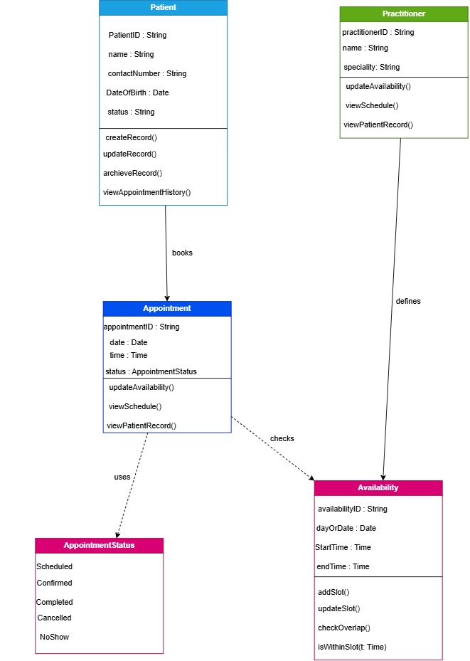Figure 1. SmartCare domain class diagram, showing Patient, Practitioner, Appointment, the optional Availability class, and the AppointmentStatus enumeration. “Made using draw.io”

Design Rationale
Four classes were kept in the domain model: Patient, Practitioner, Appointment and Availability (the optional class). Each gets back to a functional requirement in the v0.2 specification rather than being invented for completeness. Two candidate "classes" opted after reading requirements were deliberately excluded: access control (FR-08), which is a security concern rather than a business concept with its own identity and behaviour, and "operational report" (FR-12), which is a assumptions described as a summary generated rather that a persistent object.
Appointment as an association class. Appointment is modelled as its own class rather than as an attribute of Patient or Practitioner because it has independent identity (an appointmentID), its own state (status), its own lifecycle (book → reschedule/cancel → complete), and it must exist even if we later want to query "all appointments for a practitioner on a date" without going through a specific patient. Status is typed by the AppointmentStatus enumeration (Scheduled, Confirmed, Completed, Cancelled, NoShow).
Availability could have been modelled as a pair of attributes on Practitioner (e.g. workingHoursStart/End), but that would not support a practitioner having several distinct slots across different days, nor would it give conflict checking behaviour (checkOverlap(), isWithinSlot()) a natural home. Making it a separate class, associated with Practitioner, keeps Practitioner focused on identity/role information and lets Availability own the scheduling rules that functional requirements describe.
Responsibility allocation. Conflict detection is placed on Appointment (checkConflict()) rather than on Availability, because the trigger for the check is always “a new/changed appointment,” and Appointment is best placed to collaborate with Availability to answer the question. Overlap detection when a practitioner edits their own hours is placed on Availability itself, since that check does not involve any specific appointment. This split avoids putting all scheduling logic in one overloaded class.
Appointment reflect that a person can have many appointments over time but each appointment has exactly one patient and one practitioner (per the Stage 2 assumption that group consultations are out of scope). Availability allows a practitioner to define multiple slots (e.g. one per day). The Appointment Availability and Appointment AppointmentStatus links are shown as dependencies rather than persistent association.

AI Design Review Record
AI suggestion | Evidence | Decision | Reason | Model change
Add a "Room" or "Clinic Location" class so appointments can be tied to a specific room. | Not evidenced, The SmartCare brief and requirements never mention multiple rooms or locations | Reject (for v1) | No stakeholder need or requirement supports it | None.
Model "Cancellation Reason" as an attribute of Appointment. | Weakly evidenced FR-07 only says appointments can be cancelled | Reject (for v1) | Adding this attribute now would silently convert an unconfirmed assumption into a modelled requirement. | None. Flagged as an open question.
Separate "Cancelled" and "Rescheduled" as distinct status values rather than treating a reschedule as cancel + rebook. | Strongly evidenced, client brief names inconsistent appointment status as a core pain point | Accept | Directly supported by the brief and keeps the appointment history accurate as a rescheduled appointment is not the same event as a cancellation. | Appointment.reschedule() kept as a distinct behaviour from cancel(); AppointmentStatus enumeration values kept separate rather than merged.
Give Availability its own identity/table instead of storing slots as a list inside Practitioner. | Evidenced in functional requirements FR-04 and FR-13 both describe operations (update, check overlap) that only make sense if a slot is an addressable object. | Accept | Supports the checkOverlap() and isWithinSlot() responsibilities cleanly | Availability added as the optional class with its own CRC card and a association from Practitioner.
Add role-based classes (Admin, Doctor, Nurse) instead of a single generic Practitioner/Staff distinction. | Not evidenced, the case study and Stage 2 requirements only distinguish "practitioner" and "administrative staff" as actors, with no different responsibilities described. | Reject (for v1) | Introducing sub-types with no requirement behind them would add unnecessary complexity and make something which’s not required by stakeholder | None, Practitioner kept as a single class.

